Adobe FRL Online Proxy User Guide

# Overview

The FRL Online Proxy is a simple solution for managing feature-restricted Adobe licenses in an isolated network. It is a terminating reverse proxy that facilitates license management for client machines that have restricted online access.

FRL-Online licenses must, at a minimum, connect to Adobe’s licensing service once to activate a license, and again to deactivate the license. This presents a challenge for networks that have limited or no access to the Internet. On isolated networks, it may be infeasible or even impossible to facilitate access to Adobe’s licensing servers.

FRL Online Proxy solves this problem by brokering requests to the licensing service on behalf of any client on the network.

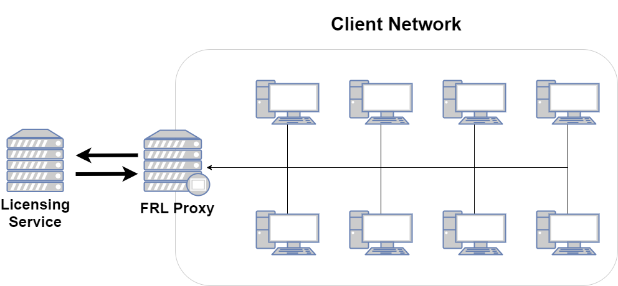

Network Layout Diagram

## Setup Overview

1. Set up a server to run FRL Online Proxy
2. Install the proxy
3. Acquire or generate SSL certificates if needed
4. Run the proxy
5. Set up logging if desired
6. Run the proxy as a service
7. Create and deploy proxy-enabled packages

# Set up a server

FRL Online Proxy will run on any modern Windows or Linux server. This server must be part of the isolated network and be able to communicate with Adobe’s licensing service (https://lcs-cops.adobe.io). It does not require Internet access to any other host or service.

We recommend creating a dedicated user account to run the proxy service. Note that it may be necessary to elevate this account’s privileges if the proxy needs to listen on port 443.

Regardless of the port that will be used, the system must be configured to allow traffic from any host on the desired port.

# Installing the Proxy

1. Obtain the latest release for the target platform.
2. Extract the release package to some root directory on the server (e.g. home directory).
3. The proxy application binary (frl-proxy or frl-proxy.exe depending on platform) and associated utilities can be found in the frl-proxy directory.

# Running the Proxy

The proxy service and associated tools are designed to be used from the command-line.

Open a command-line terminal on the server and switch to the frl-proxy directory.

$ cd /path/to/frl-proxy

Start the proxy with the start command.

# Windows  
> .\frl-proxy.exe start  
  
# Linux  
$ ./frl-proxy start

Starting the proxy with no additional command-line or config options will use the service’s default settings.

* **Host:** localhost (127.0.0.1) on port 3030
* **Remote Host (Adobe licensing server):** https://lcs-cops.adobe.io
* SSL disabled
* Log to console only at info level

The host IP should generally be 0.0.0.0 - this will let the proxy accept traffic from client machines.

$ ./frl-proxy start --host 0.0.0.0:8080

## Command and usage summary

The proxy application currently supports two commands.

init-config Create a template config file  
 start Start the proxy server

* **init-config**: Write a template config to the current directory (see Proxy configuration for more information).
* **start**: Start the service

The start command has some additional command-line options that govern proxy behavior.

-c, --config-file <config-file> Path to optional config file  
 --host <host> Proxy hostname  
 --remote-host <remote-host> Remote (licensing server) hostname  
 --ssl <ssl> Enable SSL? (true or false)  
 --ssl-cert <ssl-cert> Path to SSL certificate  
 --ssl-key <ssl-key> Path to SSL private key

# SSL

The proxy supports plain (non-SSL) mode for testing and debugging, but must use SSL with FRL-Online packages.

SSL mode requires an X.509 SSL certificate and RSA or pkcs8 private key. These should be placed on the server in a secure part of the filesystem in a place where the proxy can access them.

Consult your organization’s network security team if you need to use an organization certificate. Free cerftificates can be obtained from [Let’s Encrypt](https://letsencrypt.org/).

SSL can be enabled by setting the command-line option --ssl true and setting the paths to the private key and certificate file with --ssl-key and --ssl-cert respectively.

Example:

$ ./frl-proxy --ssl true --ssl-cert /path/to/cert.pem --ssl-key /path/to/key.pem

This will start the proxy with SSL (https) enabled, listening on the default https host/port, https://127.0.0.1:3030.

**Note:** If the option --ssl true is in use, then the key and certificate paths must be specified. If they are specified when The --ssl option is omitted or --ssl false is specified, then those options are ignored and the server will start in plain (http) mode.

# Proxy configuration

FRL Online Proxy supports an optional configuration file. This config file can be used to specify any command-line option used to start the proxy. It can also be used to control logging.

The init-config command will generate a template config file. By default, this file will be named config.toml and be placed in the current working directory.

$ ./frl-proxy init-config  
Created config file 'config.toml'

The -o/--out-file option overrides the default output path and filename.

$ ./frl-proxy init-config --out-file /path/to/my-frl-config.toml  
Created config file '/path/to/my-frl-config.toml'

To use the configuration file when starting the proxy, pass the -c/--config-file option.

$ ./frl-proxy --config-file config.toml  
or  
$ ./frl-proxy -c config.toml

## Example configuration file

[proxy]  
# Settings to invoke proxy server  
host = "0.0.0.0:8080"  
remote_host = "https://lcs-cops.adobe.io"  
ssl = true  
ssl_cert = "/path/to/ssl_cert.pem"  
ssl_key = "/path/to/ssl_key.pem"  
  
[logging]  
# Logging settings  
console_log_level = "debug"  
log_to_file = true  
file_log_level = "info"  
file_log_path = "frl-proxy.log"

## Proxy options

The configuration options in the [proxy] section of the config file govern proxy behavior. Each option has an analagous command-line option.

**Note:** Each of these options are overridden by its respective command-line option. For example, if SSL is enabled in the config file and --ssl false is passed in the command line, then the proxy will start in plain (http) mode.

|  |  |
| --- | --- |
| Option | Purpose |
| host | The host IP and port the proxy listens on. Format: [host IP]:[port]**Default:** 127.0.0.1:3030 |
| remote_host | Adobe Licensing Service endpoint**Default:** https://lcs-cops.adobe.io**Note:** This will probably never need to be overridden except to debug network communication issues |
| ssl | Enable (true) or disable (false) SSL.**Default:** false |
| ssl_cert | (optional) Path to SSL certificate file. Required if ssl is true and ignored otherwise |
| ssl_key | (optional) Path to SSL key file. Required if ssl is true and ignored otherwise |

## Logging options

Options in the [logging] section govern logging behavior. By default, the proxy will log to the console (stdout) at the info verbosity level. The config can be used to change the console logging verbosity level or write log data to a file at a potentially different verbosity level.

|  |  |
| --- | --- |
| Option | Purpose |
| console_log_level | Set the verbosity level for console log output**Default:** info |
| log_to_file | Enable (true) or disable (false) file logging**Default:** false |
| file_log_level | Set the verbosity level for file log output. Ignored if log_to_file is false**Default:** info |
| file_log_path | Filename for file log output. Ignored if log_to_file is false**Default:** frl-proxy.log (current working directory) |

**Verbosity settings**

The log verbosity level governs the nature and amount of information that is written to the log. The proxy supports five levels, which can be set in the config file. Log messages are prioritized based on message type - setting verbosity to a certain level will write messages at that level’s priority and anything above it. For example, setting the level to warn will output warnings and errors.

|  |  |  |
| --- | --- | --- |
| Level | Priority | Purpose |
| error | 1 | Errors that impact the performance or reliability of the application |
| warn | 2 | Warnings that may indicate an issue, but should not impact general performance or reliability |
| info | 3 | Useful messages |
| debug | 4 | Lower-priority messages that may be useful for debugging purposes |
| trace | 5 | Low-level application debugging information |

# Running as a service

To ensure the highest level of availability and reliability, the proxy should be run as a service. This ensures that the proxy is always running. If the service is interrupted for any reason (such as system reboot), it will automatically restart.

There are different methods for installing and enabling the proxy as a service depending on the environment.

## Windows

Windows realeases of FRL Online Proxy include tools for setting up the service. The script bin\service.ps1 provides a simple interface for managing the proxy as a service.

Example:

> .\service.ps1 start  
Service "FRL Online Proxy" installed successfully!  
FRL Online Proxy: START: The operation completed successfully.

Notes:

* Windows Powershell is required to run service.ps1
* Administrator rights are required to install the service, so run service.ps1 from a Powershell Admin console.
* service.ps1 must be run from the frl-proxy working directory
* A config file is required with the filename config.toml. This file must be in the same working directory as frl-proxy.exe and service.ps1. See Proxy configuration for more information.

Commands:

|  |  |
| --- | --- |
| Command | Purpose |
| start | Install and start the proxy as a service. |
| stop | Stop the proxy service |
| restart | Restart the proxy service |
| remove | Stop the service if necessary and remove from the registry |

When the service is installed and running, you can view the status of the service in Windows Service Manager.

1. Open the run dialog - Windows Key + R
2. Enter the command services.msc
3. Press Enter
4. The Service Manager will open showing a list of services installed on the system
5. Ensure that FRL Online Proxy is installed, running and has a Startup Type of “Automatic” 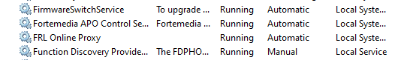

If something doesn’t work as expected, see Getting help.

## Linux

On Linux systems, the easiest way to set up a service for the proxy is (systemd)[https://systemd.io/].

**Note:** sudo privileges are required for many of these steps. We recommend creating or designating a non-privileged user account that will run the proxy and own the configuration and log files.

1. Download the latest release to the desired system.
2. Extract the frl-proxy binary to a system binary directory such as /usr/bin
3. Generate a config file (see Proxy configuration)
4. Open the config file in a text editor and configure proxy and logging settings (host, ssl settings)
   * If the proxy will be run by a non-privileged account, it is necessary to set the proxy to listen on a port number higher than 1024 (e.g. 4343)
   * The config file should be copied to a system data directory (we recommend /etc/frl-proxy)
   * The log file should be written to a system log directory such as /var/log (we recommend /var/log/frl-proxy)
5. If you are going to run the proxy as a non-privileged user, change ownership of config file and log directory. Replace [user] and [group] with the user and group of the non-privileged account.
   * sudo chown [user]:[group] /etc/frl-proxy/config.toml
   * sudo chown -R [user]:[group] /var/log/frl-proxy
6. Create the service configuration file /etc/systemd/system/frl-proxy.service and open it in a text editor
7. Copy this example configuration to the editor. Be sure to change the paths to the proxy binary and config file if necessary. And replace [user] with the name of the account that will run the proxy.

* [Unit]  
  Description=FRL Online Proxy  
  After=network.target  
  StartLimitIntervalSec=0  
    
  [Service]  
  Type=simple  
  Restart=always  
  RestartSec=1  
  User=[user]  
  ExecStart=/usr/bin/frl-proxy start -c /etc/frl-proxy/config.toml  
    
  [Install]  
  WantedBy=multi-user.target

With the service config in place, the service can be controlled with systemctl. Here are some examples of how to manage the service.

# Enable/disable determines if the service will start on boot  
sudo systemctl enable frl-proxy  
sudo systemctl disable frl-proxy  
  
# Start/stop will manually start and stop the service, restart will stop and then start it  
sudo systemctl start frl-proxy  
sudo systemctl stop frl-proxy  
sudo systemctl restart frl-proxy  
  
# If any changes are made to the frl-proxy.service config, the systemd daemon must be reloaded  
sudo systemctl daemon-reload

If something doesn’t work as expected, see Getting help.

# Creating proxy-enabled packages

FRL-Online packages must be configured to use the proxy. Proxy settings are managed in the Adobe Admin Console.

1. Log into the [Admin Console](https://adminconsole.adobe.com)
2. Click the “Packages” tab on the top navigation bar.
3. Click the blue “Create a Package” button.
4. Select “Feature restricted licensing” and then “Next”
5. Select “Online” and then “Next”
6. Select entitlement, OS and product (app) options
7. On the next page, under “Management Options”, select “Contact Adobe through a reverse proxy”

* 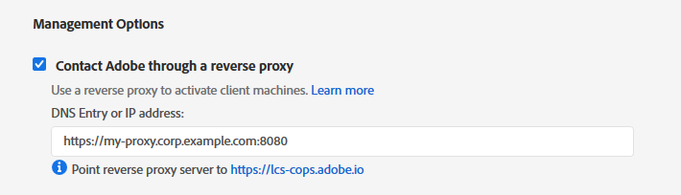
* Proxy Setting
* Update the “DNS Entry or IP address” field to point to the FRL Online Proxy service. This can be a plain IP address or a hostname. Don’t forget to specify the port number if using a non-standard port.

# Getting help

FRL Online Proxy is currently in pre-release. If you experience any issues or challenged using this solution, please reach out to your Adobe relationship specialist.